Greater Toledo USBC Association Adult City Championship Rules
- Only ADULT members, certified through the Greater Toledo USBC Association, are eligible to compete. Bowlers must have proof of membership at check-in or pay $27.00 membership fee. All participants must also be at least 18 years of age to participate in this tournament.
- (A) All bowlers must enter at their highest GTUSBCA certified average, for 21 games, from 2021-22 season.
(B) If no GTUSBCA average for 2021-22 season, bowlers must use highest current certified average for 21 games or more, as of the start of the tournament. Provide written verification if using current average.
(C) Former youth members who become adult cardholders during the current season will use highest certified youth average from last season or current GTUSBCA average of 21 games, as of the tournament start date, whichever is higher. Provide written verification if using current average.
(D) Summer GTUSBCA averages of 21 or more games will be accepted if rule 2(A), (B), or (C) does not apply. Provide written verification if using current average.
(E) Those not meeting the above requirements of rule 2 enter at 230 average.
(F) Rule 319-a2 will not apply, however rule 319e does apply. See USBC rulebook for complete rule.
3. This tournament will be conducted on a handicap basis; the handicap is 90% of the difference between the entering average and 920 for team; 460 for doubles and 230 for singles.
4. A maximum of two bowlers together, on different teams, may cash twice in each division. A maximum of 1 card carrying PBA or PWBA member is allowed per team.
5. Doubles will be bowled first then singles. You may bowl doubles only or singles only at the time stated for each event. You may bowl in the minor events more than once, and can elect doubles and/or singles each shift, if openings are available. A bowler may cash twice per division in the doubles with different partners. A doubles team may bowl together more than once but cash only once. A doubles team may have only one card-carrying PBA or PWBA member. A bowler may cash only once per division on the singles prize list.
6. Your first series in each event will be your all-events score. All-events will be based on handicapped score.
Optional $10 All-events scores are figured on actual pin fall for nine games.
7. Prize ratio will be at least 1 out of 7. Prize fee returned 100%.
8. Reserved entries must be prepaid to assure spot. Walk-in entries will be accepted if space is available. You may bowl only once per shift.
9. USBC rules will apply to all rules not covered above. Tournament Director, or their representative, will resolve all disputes and that decision is final.
10. There will be a $30.00 fee for returned checks.

TOURNAMENT OFFICIALS RESERVE THE RIGHT TO HOLD RANDOM BOWLING BALL
INSPECTIONS AT ANY POINT DURING THE COMPETITION

THIS IS A MULTIPLE PARTICIPATION TOURNAMENT, LIMITED ONLY BY SPACE AVAILABILITY

Only fully paid entries are guaranteed squad times.
No entry fees will be returned after the start of the Tournament.

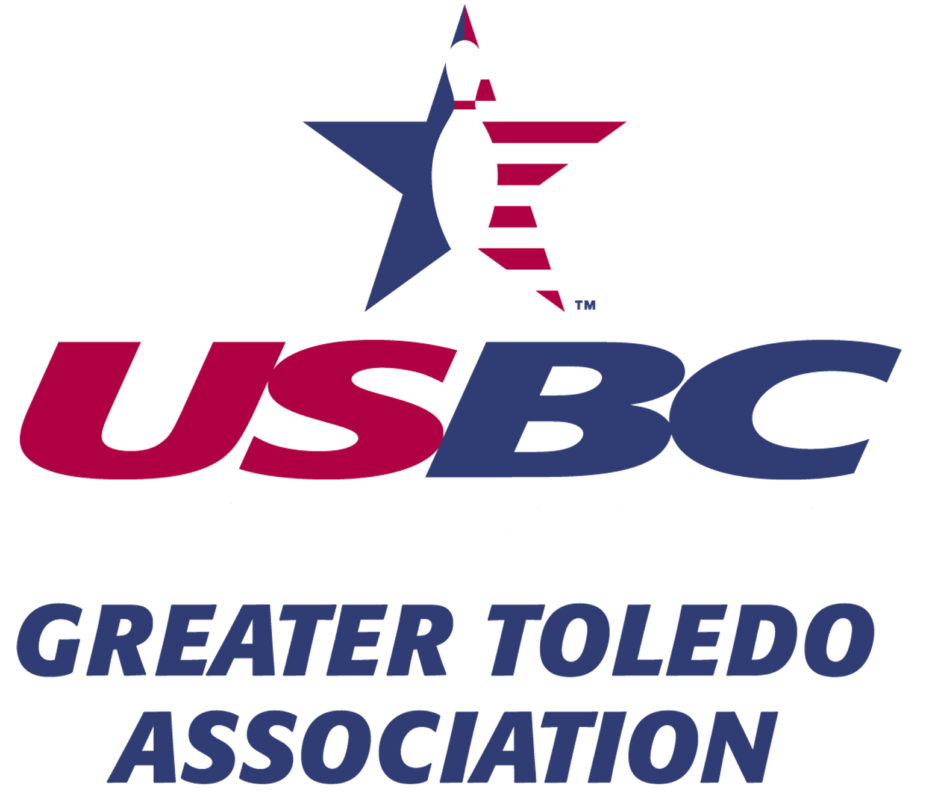
TEAM EVENT DOUBLES & SINGLES
Toledo Sports Center Interstate Lanes
1516 Starr Ave 819 Lime City Rd.
Toledo, OH 43605 Rossford, OH 43460
February 19, 25 and 26, 2023 March 18, 19 and 26, 2023

Email: gtba@accesstoledo.com Website: www.toledobowling.com

Phone: 419-537-0523 or 419-536-2007

